1. Find ten health problem and treatment words in the word search.

T | A | R | F | C | I | P | C | A
C | O | L | D | O | L | R | T | E
M | V | O | U | U | D | R | A | S
E | K | I | T | G | R | E | C | N
A | A | S | T | H | M | A | R | E
S | A | Z | I | P | A | L | A | E
L | P | I | L | L | S | C | S | Z
E | V | E | A | R | A | C | H | E
S | W | B | A | N | D | A | G | E

2. Find the odd one out.

1 cold – cough – rash – stuffy nose
2 fever – backache – earache - headache
3 chicken pox – headache – measles - rash
4 injection – medicine – syrup – X-ray
5 acupuncture – hospital – massage – diet
6 bleed – dentist – doctor - nurse

3. Put the letters in the correct order.

1 aaheecr: _________________
2 gtnrheic: _________________
3 tiismvan: _________________
4 horetsotar: _________________
5 oeinintjc: _________________
6 uyrps: _________________
7 nolrgeebk: _________________
8 ecpixhnko: _________________
9 ohoatehtc: _________________
10 ndcmieei: _________________

4. What are they?

dizzy sneeze fever measles bandage

1 An illness that makes small red spots come on your skin: _____________
2 If you have it, your body is too hot because you are ill: ______________
3 If you feel it, you feel that everything is turning round and round and that you are going to fall: _______________
4 A long piece of white cloth that you put around a part of the body that is hurt: ______________
5 Send air out of your nose and mouth with a sudden loud noise, for example because you have a cold: ____________

5. Look at the pictures and write appropriate advice for each.

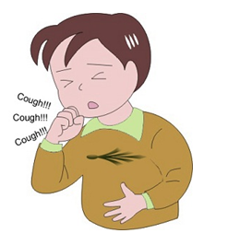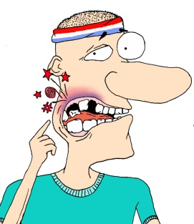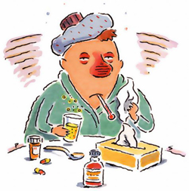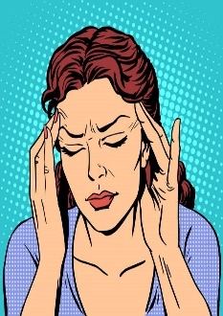
1)Mike has a sore throat. He should go to doctor.
2)Hans___________________________________________________________________________________________________________________
4)Khan___________________________________________________________________________________________________
5)Murat________________________________________________________________________________
3)Lisa__________________________________________________________________________________________________________________
6)Ted__________________________________________________________________________________________________________________

6. Choose from the advice below
- You look terrible.I think you _____________________.
- You work at the office until 11 o’clock every night this week.You_____________________.
- It’s Jane’s birthday on Saturday so I think we _____________________.
- Listen to the terrible cough.She _____________________.
- He always gives you the wrong advice.You ___________________________.
- My train leaves at 6 o’clock tomorrow morning so I _____________________.
- Your hair is in your eyes.Don’t you think you _____________________?
- Everything will be all right.You _____________________.

not worry so much

have a party
a haircut

have a haircut

see a doctor

tell him that
(2)

not listen to him
go to bed early tonight
flying colours (2)

stop smoking
not work so hard

