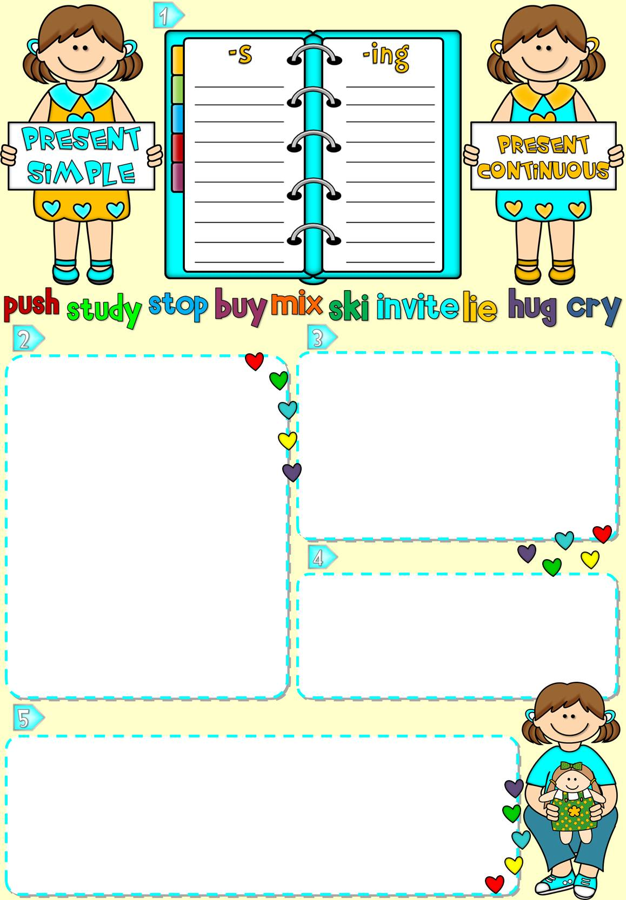

**Add** -s **and** -ing **to the verbs.**

**Order the words to make sentences.**

1. drinking / I / now / juice / . / am / orange

_ _ _ _ _ _ _ _ _ _ _ _ _ _ _ _ _ _ _ _ _ _ _ _ _ _ _ _ _

1. golf / . / a week / Jim / once / plays

_ _ _ _ _ _ _ _ _ _ _ _ _ _ _ _ _ _ _ _ _ _ _ _ _ _ _ _ _

1. play / are / . / today / rehearsing / a school / we

_ _ _ _ _ _ _ _ _ _ _ _ _ _ _ _ _ _ _ _ _ _ _ _ _ _ _ _ _

1. you / for / are / ? / who / waiting

_ _ _ _ _ _ _ _ _ _ _ _ _ _ _ _ _ _ _ _ _ _ _ _ _ _ _ _ _

1. every / visit / your cousins / week / do / ? / you

_ _ _ _ _ _ _ _ _ _ _ _ _ _ _ _ _ _ _ _ _ _ _ _ _ _ _ _ _

1. always / a nap / they / the afternoon / have / in /.

_ _ _ _ _ _ _ _ _ _ _ _ _ _ _ _ _ _ _ _ _ _ _ _ _ _ _ _ _

1. now / aren’t / the birds / watching/ . / we

_ _ _ _ _ _ _ _ _ _ _ _ _ _ _ _ _ _ _ _ _ _ _ _ _ _ _ _ _

1. goes /. / bus / to / Alice / school / usually / by

_ _ _ _ _ _ _ _ _ _ _ _ _ _ _ _ _ _ _ _ _ _ _ _ _ _ _ _ _

1. TV / the moment / is / at / who / ? / watching

_ _ _ _ _ _ _ _ _ _ _ _ _ _ _ _ _ _ _ _ _ _ _ _ _ _ _ _ _

10. uniform / they / wear / school /. / don’t

_ _ _ _ _ _ _ _ _ _ _ _ _ _ _ _ _ _ _ _ _ _ _ _ _ _ _ _ _

**Write** am**,** is**,** are**,** do **or** does**.**

1. We _ _ _ _ having a music lesson at the moment.
2. _ _ _ _ Helen your best friend? Yes, she _ _ _ _ .
3. Where _ _ _ _ you usually spend your holidays?
4. Who likes sea food? My father _ _ _ _ .
5. I _ _ _ _ on the phone. I _ _ _ _ talking to Pam.
6. Why _ _ _ _ Andy crying? He’s hurt his arm.
7. How often _ _ _ _ your parents go to the opera?
8. Jack and I _ _ _ _ in my bedroom. We _ _ _ _ sitting at the table and we _ _ _ _ playing chess.
9. _ _ _ _ your sister share a room with you?

10. Where _ _ _ _ you going? To the supermarket.

**Complete the sentences with the Present Simple or Continuous form of the verbs.**

1. I _ _ _ _ _ _ _ _ my hands because they’re dirty. (**wash**)
2. Tracy _ _ _ _ _ _ _ _ rock star posters. (**collect**)
3. _ _ _ _ _ _ _ _ the tomatoes for spaghetti? (**cut**, **you**)
4. My dad _ _ _ _ _ _ _ _ the plants in the garden at the moment. (**water**, **not**)
5. _ _ _ _ _ _ _ _ resting on a hammock? (**like**, **you**)

**Choose the correct option.**

1. Liz **wakes** - **is** **waking** up at 8.15 every morning.
2. My teacher **wears** - **is** **wearing** a nice dress today.
3. I **play** - **am** **playing** with my friends after school.
4. My brothers **make** - **are** **making** a model plane now.
5. **Do** **you** **meet** - **Are** **you** **meeting** your friends this weekend?
6. I **watch** - **are** **watching** TV in the evening.
7. My mum _ _ _ _ _ _ _ _ my uniform skirt now. (**iron**)
8. I never _ _ _ _ _ _ _ _ coffee after seven in the afternoon. (**drink**)
9. We _ _ _ _ _ _ _ _ our grandparents very often, at least once a week. (**visit**)
10. What _ _ _ _ _ _ _ _ before she _ _ _ _ _ _ _ _ for school? (**do**, **Molly**, **leave**)

10. Greg and I _ _ _ _ _ _ _ _ a kite in the

playground right now. (**fly**, **not**)



**Add** -s **and** -ing **to the verbs.**

**Order the words to make sentences.**

1. drinking / I / now / juice / . / am / orange

**I am drinking orange juice now.**

1. golf / . / a week / Jim / once / plays

**Jim plays golf once a week.**

1. play / are / . / today / rehearsing / a school / we

**We are rehearsing a school play today.**

1. you / for / are / ? / who / waiting

**Who are you waiting for?**

1. every / visit / your cousins / week / do / ? / you

**Do your cousins visit you every week?**

1. always / a nap / they / the afternoon / have / in /.

**They always have a nap in the afternoon.**

1. now / aren’t / the birds / watching/ . / we

**We aren’t watching the birds now.**

1. goes /. / bus / to / Alice / school / usually / by

**Alice usually goes to school by bus.**

1. TV / the moment / is / at / who / ? / watching

**Who is watching TV at the moment?**

10. uniform / they / wear / school /. / don’t

**They don’t wear school uniform.**

**Write** am**,** is**,** are**,** do **or** does**.**

1. We **are** having a music lesson at the moment.
2. **Is** Helen your best friend? Yes, she **is** .
3. Where **do** you usually spend your holidays?
4. Who likes sea food? My father **does** .
5. I **am** on the phone. I **am** talking to Pam.
6. Why **is** Andy crying? He’s hurt his arm.
7. How often **do** your parents go to the opera?
8. Jack and I **are** in my bedroom. We **are** sitting at the table and we **are** playing chess.
9. **Does** your sister share a room with you?

10. Where **are** you going? To the supermarket.

**Complete the sentences with the Present Simple or Continuous form of the verbs.**

1. I **am washing** my hands because they’re dirty. (**wash**)
2. Tracy **collects** rock star posters. (**collect**)
3. **Are you cutting** the tomatoes for spaghetti? (**cut**, **you**)
4. My dad **isn’t watering** the plants in the garden at the moment. (**water**, **not**)
5. **Do you like** resting on a hammock? (**like**, **you**)

**Choose the correct option.**

1. Liz **wakes** - **is** **waking** up at 8.15 every morning.
2. My teacher **wears** - **is** **wearing** a nice dress today.
3. I **play** - **am** **playing** with my friends after school.
4. My brothers **make** - **are** **making** a model plane now.
5. **Do** **you** **meet** - **Are** **you** **meeting** your friends this weekend?
6. I **watch** - **are** **watching** TV in the evening.
7. My mum **is ironing**  my uniform skirt now. (**iron**)
8. I never **drink** coffee after seven in the afternoon. (**drink**)
9. We **visit** our grandparents very often, at least once a week. (**visit**)
10. What **does Molly do** before she **leaves** for school? (**do**, **Molly**, **leave**)

10. Greg and I **aren’t flying** a kite in the

playground right now. (**fly**, **not**)

**pushes**

**studies**

**stops**

**buys**

**mixes**

**skis**

**invites**

**lies**

**hugs**

**cries**

**pushing**

**studying**

**stopping**

**buying**

**mixing**

**skiing**

**inviting**

**lying**

**hugging**

**crying**