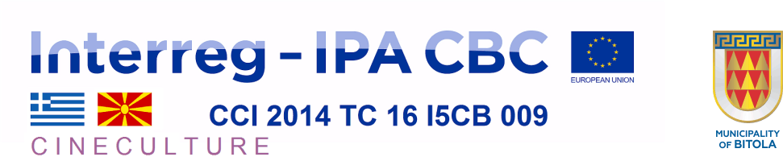

LIST OF ENTITIES INVITED TO SUBMIT A TENDER
“Study of touristic valorization of cultural and national heritage in cross border area”
Municipality of Bitola, Pelagonia region, Republic of North Macedonia, project CINECULTURE
- Faculty of Tourism and Hospitality – Ohrid, University “St. Kliment Ohridski” – Bitola, Kej Makedonija 95, MK-6000 Ohrid, ftu@uklo.eu.mk www.ftu.uklo.edu.mk
- Global Project Consulting, Guro Gakovic 62/3, MK-1000 Skopje, globalproektkonsalting@gmail.com, www.gpm.com.mk
- Macedonian Science Society – Bitola, Pece Matichevski 39, MK-7000 Bitola, mss.bitola@gmail.com, www.mnd-bitola.mk
- Multi Impex – Bitola, Pece Matichevski 38, MK-7000, Bitola, info@multiimpex.com.mk, www.multiimpex.com.mk
- University of Tourism and Management – Skopje, bul. Partizanski Odredi bb, MK-1000 Skopje, contact@utms.edu.mk, www.uts.edu.mk

- Any other organization on the basis of public announcement of the contract.

